March 2, 2018
Today OLF and the Lions of OH7 [with Trustee Jacky Grimm from OH3] presented a Braille Note 18 machine to Kaitlin Shelton, a music therapy major at U of Dayton doing her internship in Cleveland. She was overjoyed with the device. She stated “I have all weekend to learn how to use” & she will use it in her upcoming career.
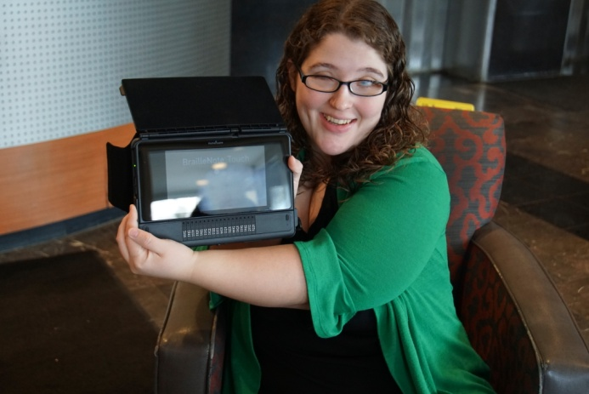
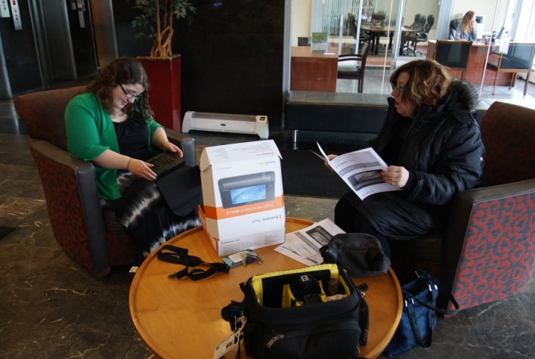
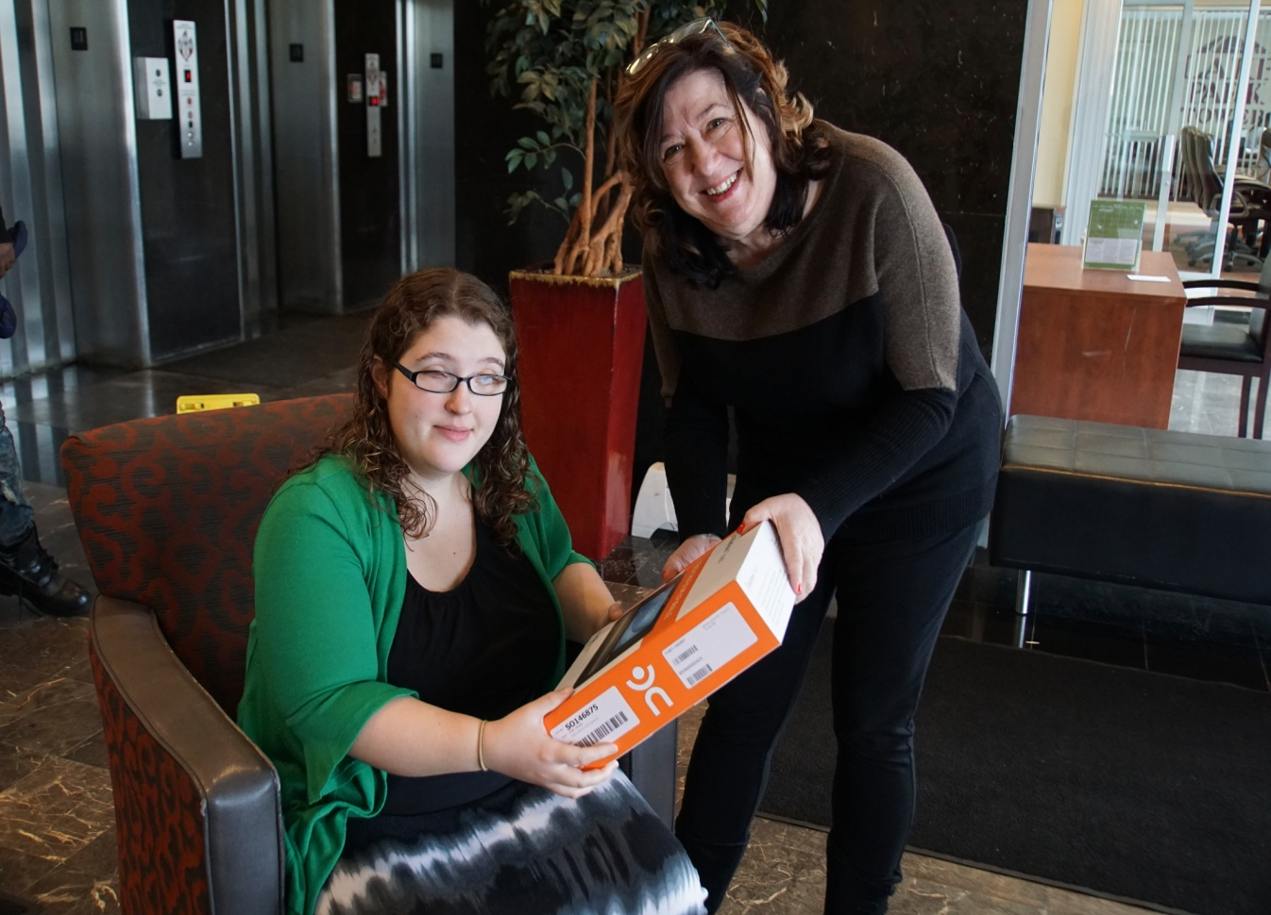
Lion Jacky Grimm helps Kaitlin go over the start up manual for the Braille Note 18 device.
