NEWS…December 2019
Your OLF at work!
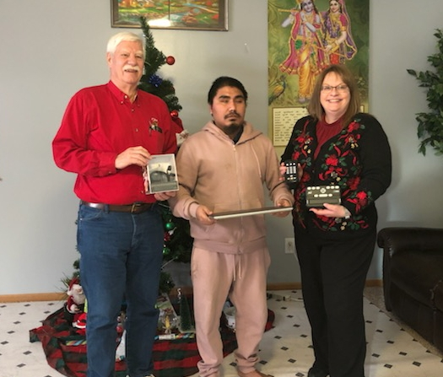

OLF Trustee Ben Cosgray and Lion Lilane Fox of the Pickerington Club partnered to get Amrit Tiwari a new laptop, Jaws software, an Orbit braille display unit and a Victor/Trek device. The attached picture shows us delivering the items to Amrit. The Pickerington Lions Club bought the laptop and we (OLF) supplied the rest.

Amrit was most grateful.

